DE–1733
11
DISTANCE EDUCATION
M.Sc. (Mathematics) DEGREE EXAMINATION, MAY 2011.
ALGEBRA
Time : Three hours Maximum : 100 marks
Answer any FIVE questions.
All questions carry equal marks.
(5 × 20 = 100)
- (a) If H and K are finite subgroups of G of orders 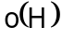 and 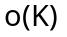, respectively, prove that 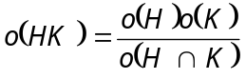.
(b) If G is a finite abelian group and 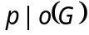, where p is a prime number prove that there is an element 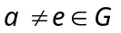 such that 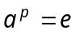.
- (a) If 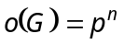 where p is a prime number then prove that 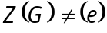.
(b) State and prove third part of Sylow’s theorem.
- (a) If G is the internal direct product of 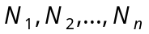 prove that for 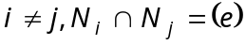, and if 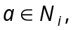 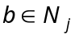 then 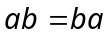.
(b) Prove that G is the internal direct product of the normal subgroups if and only if
(i) 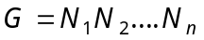
(ii) 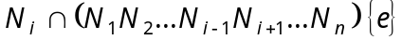 for 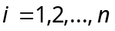.
- (a) If R is a Euclidean ring prove that any two elements and in R have a greatest common divisor d in the from of 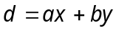 for some 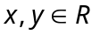.
(b) If R is a Euclidean ring and A is an ideal of R prove that there exists an element 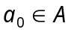 such that A consists exactly of all 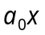 as ranges over R.
- (a) If 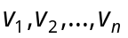 is a basis of V over F and if 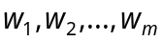 in V are linearly independent over F, then 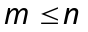.
(b) If V is finite-dimensional vector space over F and if W is a subspace of V, prove that W is finite-dimensional, 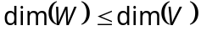 and 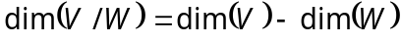.
- (a) Prove that there exists a subface W of V, invariant under T, such that 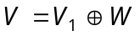.
(b) If 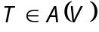 has all its characteristic roots in F, prove that there is a basis of V in which the matrix of T is triangular.
- (a) If L is finite extension of K and if K is a finite extension of F prove that L is a finite extension of F and hence prove that 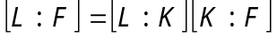.
(b) If 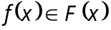 is a polynomial of degree 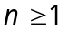, prove that there is an extension E of F of degree at most n! in which 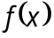 has n roots.
- (a) If K is a finite extension of F prove that 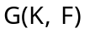 is a finite group and its order 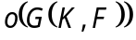 satisfies 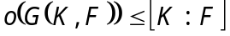.
(b) Prove that K is a normal extension of F if and only if K is the splitting field of some polynomial over F.
———————
DE–1734
12
DISTANCE EDUCATION
M.Sc. (Maths) DEGREE EXAMINATION, MAY 2011.
REAL ANALYSIS
Time : Three hours Maximum : 100 marks
Answer any FIVE questions.
All questions carry equal marks.
(5 × 20 = 100)
- (a) Prove that
(i) for any collection of open sets 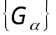, 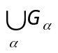 is open
(ii) for any finite collection 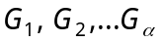 of open sets 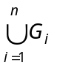 is open.
(b) Prove that compact subsets of metric spaces are closed.
- (a) Prove that a mapping of a metric space  into a metric space  is continuous if and only if 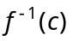 is closed in X for every closed set C in Y.
(b) Let f be a continuous mapping of a compact metric space X into a metric space Y. Then f is uniformly continuous on X.
- (a) State and prove Mean value theorem for derivatives.
(b) State and prove the inverse function theorem.
- (a) Let f be a real valued function defined on 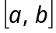. If f has a local maximum at a point 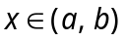 and if 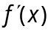 exists, then prove that 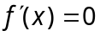.
(b) Explain the directional derivative and the total derivative.
- (a) Prove that if 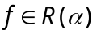 on if and only if for every 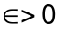 there exists a partition P such that 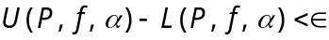.
(b) If f is continuous on , prove that on .
- (a) Prove that
(i) for every 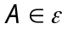, 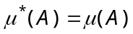
(ii) if 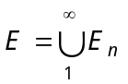, then 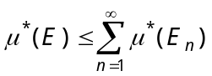
(b) Prove that if f in measurable, then 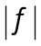 is measurable.
- (a) If 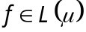 on E, prove that (i) 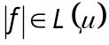 on E and (ii) 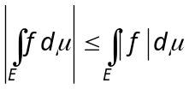.
(b) State and prove Fatou’s theorem.
- State and prove Lebesgue’s monotone convergence theorem.
————————
DE–1735
13
DISTANCE EDUCATION
M.Sc.(Mathematics) DEGREE EXAMINATION, MAY 2011.
DIFFERENTIAL EQUATIONS AND NUMERICAL METHODS
Time : Three hours Maximum : 100 marks
Answer any FIVE questions.
(5 × 20 = 100)
- Explain the method of variation of constants to find a particular solution of a non-homogeneous linear ordinary differential equation of order n with constant efficient.
- Derive the legendre differential equation.
- Explain the charpit's method and using this mehod, find the complete integral of the equation 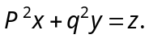
- Obtain the d'Alembert's solution of the one dimensional wave equation and interpret it physically.
- Find, using Newton's method, a root of the equation 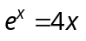 , which is approximately 2, correct to three parts of decimal. Determine the same root using regular – flase method.
- Calculate the polynomial of degree 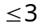 which minimizes 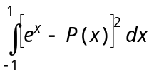over all polynomials P(x) of degree .

- Evaluate 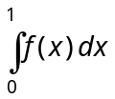 when 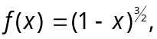using
(a) Trapezoidal rule and
(b) Simpson's 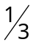 rule.
- Find the solution of the differential equation 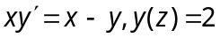 at 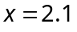 correct to five decimal places, using
(a) Taylor's method and
(b) Euler's method.
————————
14
DE-1736
DISTANCE EDUCATION
M.Sc. (Mathematics) DEGREE EXAMINATION, MAY 2011.
OPERATIONS RESEARCH
Time : Three hours Maximum : 100 marks
Answer any FIVE questions.
(5 × 20 = 100)
All questions carry equal marks.
- (a) Use simplex method to solve the LPP.
Maximize 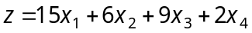
Subject to 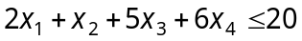
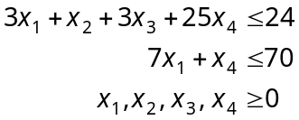
(b) Use dual simplex method to solve the LPP.
Maximize 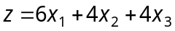
Subject to 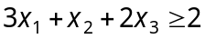
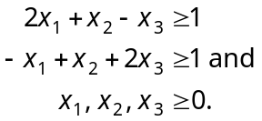
- (a) Show, by an example, that dual of the dual is primal.
(b) Find the optimum integer solution to the following LPP. maximize 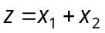 subject to the constraints
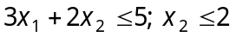; and 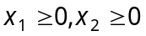 and are integers.
- (a) Solving the following LPP by dynamic programming
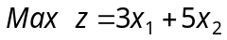 subject to the constraints
.
(b) Using dynamic programming approach solve the reliability problem with the following data.
kj j=1 j=2 j=3
 | R₁ | C₁ | R₂ | C₂ | R₃ | C₃
1 | 0.6 | 1000 | 0.7 | 3000 | 0.5 | 2000
2 | 0.8 | 2000 | 0.8 | 5000 | 0.7 | 4000
3 | 0.9 | 3000 | 0.9 | 6000 | 0.9 | 5000
Total capital available is 10,000 rupees.
- (a) Solve the following game graphically.
 | B₁ | B₂ | B₃ | B₄ | B₅
A₁ | 2 | -4 | 6 | -3 | 5
A₂ | -3 | 4 | -4 | 1 | 0
(b) Using dominance property solve the game
B
A |  | I | II | III | IV
A | 1 | -5 | 3 | 1 | 20
A | 2 | 5 | 5 | 4 | 6
A | 3 | -4 | -2 | 0 | -5
- (a) Construct the network for each of the projects whose activities and their precedence relationships are as given below.
Activity: | A | B | C | D | E | F | G | H | I | J | K
Immediate predecessor: | - | - | - | A | B | B | C | D | E | H,I | F,G
(b) Find the critical path and calculate the slack time for the following PERT diagram.
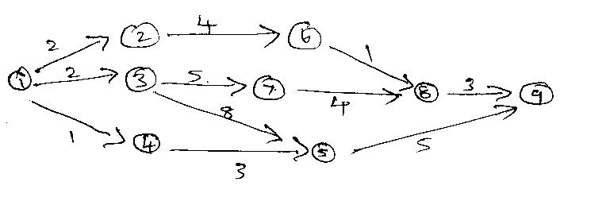
- (a) Find the optimum order quantity for a product for which the price breaks are given below.
Quantity | Purchasing cost
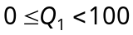 | Rs. 20/unit
 | Rs. 18/unit
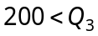 | Rs. 16/unit
The monthly demand for the product is 400 units. The shortage cost is 20% of the unit cost of the product and the cost of ordering is 25.00/month.
(b) The demand for an item in a company is 18,000 units/year. and the company can produce the item at the rate of 3000/month. The cost of setup is Rs.500 and the holding cost of one unit per month is 15 paise. The shortage cost of one unit is Rs.20/month. Determine the optimum manufacturing quantity and the number of shortages. Also find the manufacturing time and time between set up.
- (a) Explain the queuing model
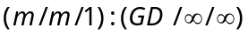
(b) A mechanic repairs four machines. The mean time between service requirements is 5 hours for each machine and forms an exponential distribution. The mean repair time is 1 hour and also follows the same distribution pattern. Find
(i) Probability that the service facility will be idle
(ii) Probability of various number of machines (0 through 4) to be and being repaired
(iii) Expected number of machines waiting to be repaired and being repaired.
(iv) Expected time a machine will wait in queue to be repaired.
- (a) For the . derive the expression for 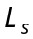 using the basic definition 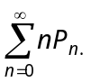
(b) Customers arrive at a thrift bank according to a poisson distribution with a mean of 45 customers per hour. Transactions per customer last about 5 minutes and are exponentially distributed. The bank wants to have a single line multiple-teller operation, similar to the ones used in airports and post offices. The manager is conscious of the fact that customers may switch to other banks if they perceive that their wait in line is ‘exclusive’. For this reason, the manager wants to limit the average waiting time in the queue to no more than 30 seconds. How many tellers should the bank provide?
——————
15
DE-1737
DISTANCE EDUCATION
M.Sc. (Mathematics) DEGREE EXAMINATION, MAY 2011.
MATHEMATICAL STATISTICS
Time : Three hours Maximum : 100 marks
Answer any FIVE questions.
All questions carry equal marks.
(5 × 20 = 100)
- (a) Given the joint pdf of 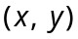 is
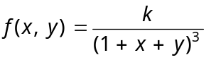 for 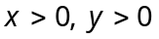
= 0 otherwise
find k, marginal and conditional distributions.
(b) Explain the principle of least squares and obtain the normal equations to fit a straight line 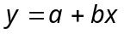.
- (a) Obtain MGF for Binomial distribution and hence find its mean and variance.
(b) Derive recurrence formula the moments of the Poisson distribution with parameter ,
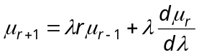.
- (a) State and prove central limit theorem.
(b) Find 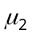 and 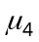 for the t distribution with n degrees of freedom, 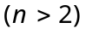.
- (a) In random sampling from normal population 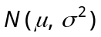 find the maximum likelihood estimators for (i) when 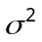 is known and (ii) when is known.
(b) State and prove Rao-Blackwell theorem.
- State and prove Neyman-Pearson lemma.
- (a) What are simple and composite hypotheses? Give examples.
(b) The average hourly wage of a sample of 150 workers in a plant ‘A’ was Rs. 2.56 with a standard deviation 1.08. The average wage of a sample of 200 workers in plant ‘B’ was 2.87 with a S.D. of 1.28. Can an applicant safely assume that the hourly wages paid by plant ‘B’ are higher than those by plant ‘A’?
- Describe the single sampling plan and derive expressions for the producer's and consumer's risks.
- (a) Describe the technique of the analysis of variance. Write down the ANOVA table for a one way layout.
(b) The following table gives quality rating of service stations by four professional raters :
Rater | Service Station
 | 1 | 2 | 3 | 4 | 5
A | 99 | 70 | 90 | 99 | 65
B | 96 | 65 | 80 | 95 | 70
C | 95 | 60 | 48 | 87 | 48
D | 98 | 65 | 70 | 95 | 67
Analyse the data and discuss whether there is any significant difference between ratings or between service stations.

——————
DE–1738
21
DISTANCE EDUCATION
M.Sc. (Mathematics) DEGREE EXAMINATION, MAY 2011.
COMPLEX ANALYSIS
Time : Three hours Maximum : 100 marks
Answer any FIVE questions.
All questions carry equal marks.
(5 × 20 = 100)
- (a) Explain stereographic projection.
(b) Prove that a linear transformation carries circles into circles.
(c) Discuss the transformation . (7 + 6 + 7)
- (a) Prove that the bilinear transformations which map 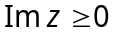 onto 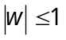 are of the form 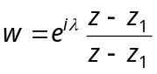, where is a real number.
(b) Discuss the transformation 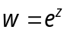.
(c) State and prove the Abel’s theorem on power series.
(6 + 6 + 8)
- (a) State and prove Taylor’s theorem.
(b) State and prove Liouville’s theorem. Deduce fundamental theorem of algebra.
- (a) State and prove Cauchy’s theorem for a rectangle
(b) Compute 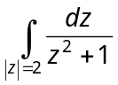 by decomposition of the integrand in partial fractions.
- (a) State and prove Rouche’s theorem.
(b) Evaluate the integral by the method of residues 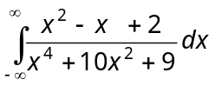.
- (a) State and prove Mittag-Leffler theorem.
(b) Derive the Legendre’s duplication formula.
- (a) Prove that 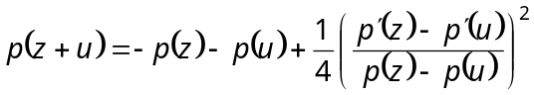.
(b) Derive the first order differential equation for 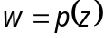.
- (a) Prove that there exists a basis 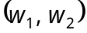 such that the ratio 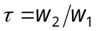. Satisfies the following conditions.
(i) 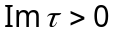
(ii) 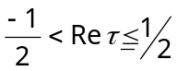
(iii) 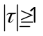
(iv) 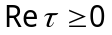 if 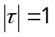. Further the ratio is uniquely determined by these conditions and there is a choice of two, four, or six corresponding bases. Prove.
(b) Prove that 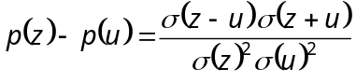.
———————
DE–1739
22
DISTANCE EDUCATION
M.Sc.(Mathematics) DEGREE EXAMINATION, MAY 2011.
TOPOLOGY AND FUNCTIONAL ANALYSIS
Time : Three hours Maximum : 100 marks
Answer any FIVE questions.
(5 × 20 = 100)
Each question carries 20 marks.
- (a) Show that every separable metric space is second countable. (10)
(b) Prove that any continuous image of a compact space is compact. (10)
- (a) State and prove Tychonoff’s theorem. (10)
(b) Prove that in a sequentially compact metric space, every open cover has a Lebesgue number. (10)
- (a) State and prove Tietze’s Extension theorem. (10)
(b) State and prove Urysohn’s imbedding theorem. (10)
- (a) Prove that a subspace of the real line R is connected it is an interval. (10)
(b) Prove that the spaces 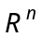 and 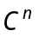 are connected. (10)
- (a) Let N be a non-zero normed linear space. Prove that N is a Banach space 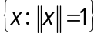 is complete. (10)
(b) State and prove Hahn-Banach theorem. (10)
- (a) Prove that every non-empty subset X of a normed linear space N is bounded if and only if f (X) is a bounded set of numbers for each f in N*. (15)
(b) If T is a linear transformation from N into itself, then prove that 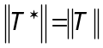, where T* is the conjugate
of T. (5)
- (a) Prove that every closed convex subset C of a Hilbert space H contains a unique vector of smallest
norm. (10)
(b) If M is a closed linear subspace of a Hilbert space H, then prove that H = 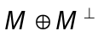. (10)
- (a) Let H be Hilbert space and f be an arbitrary functional in 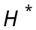. Prove that there exists a unique vector y such that 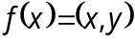, for all x in H. (10)
(b) Prove that an operator T on H is self-adjoint if and only if 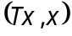 is real for all x. (10)
———————–
DE–1740
23
DISTANCE EDUCATION
M.Sc. (Mathematics) DEGREE EXAMINATION, MAY 2011.
GRAPH THEORY
Time : Three hours Maximum : 100 marks
Answer any FIVE questions.
All questions carry equal marks.
- (a) Prove that in any graph, the number of vertices of odd degree is even. (5)
(b) Using cayley’s recursive formula, find the number of spanning trees of 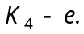 (5)
(c) Show that if G is a simple graph on atleast three vertices with then G is Hamiltonian. (10)
- (a) Show that if G has a Hamilton path, then for every proper subset S of 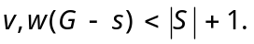 (10)
(b) Prove that connectivity equals edge connectivity for a simple cubic graph. (5)
(c) Define closure of a graph and prove that it is
well-defined. (5)
- (a) Establish cayley’s formula for number of spanning trees. (10)
(b) Prove that a graph G with 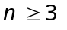is 2- connected if and only if any two vertices of G are connected by atleast two internally disjoint paths. (10)
- (a) Prove that 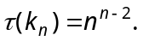 (10)
(b) Prove that the graph 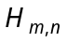 is m-connected. (10)
- (a) Define Ramsey’s numbers. Prove that 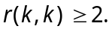
(10)
(b) If G is a tree with n vertices, prove that 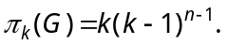 (10)
- (a) State and prove Five colour theorem. (10)
(b) If G is k-critical, prove that 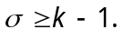 (5)
(c) Find the edge chromatic number of petersen graph.
(5)
- (a) Show that the graph 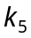 is non-planar. (10)
(b) Let G be a nonplanar connected graph that contains no subdivision of or 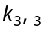 and few edges as possible. Then prove that G is simple and
3-connected. (10)
- (a) If D is strict and min 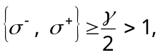
prove that D contains a directed Hamilton cycle. (10)
(b) State and prove Max-flow Min-cut theorem. (10)
————————
DE–1741
24
DISTANCE EDUCATION
M.Sc. (Mathematics) DEGREE EXAMINATION, MAY 2011.
PROGRAMMING IN C/ C++
Time : Three hours Maximum : 100 marks
Answer any FIVE questions.
All questions carry equal marks.
(5 × 20 = 100)
- (a) What are the advantages of C? Explain. (10)
(b) What are the steps inn computer programming? (10)
- (a) Describe the basic structure of a C program. (10)
(b) How do you declare a variable and assign values?
(10)
- (a) Explain the input functions scanf ( ), getchar ( ) and gets ( ). (10)
(b) Write a program that inputs a number, then displays the address where the number is stored in memory. (10)
- (a) Explain arithmetic operators and order of precedence with example. (10)
(b) Explain the difference between automatic and external variables. (10)
- (a) Explain in detail for loops with examples. (10)
(b) Distinguish between DO and WHILE loops. (10)
- (a) Write a program to find the roots of a quadratic equation. (10)
(b) Write a program to multiply two given matrices.
(10)
- (a) How do you initialize a structure? Can you have an array of a structure? (10)
(b) What do you understand by a pointer? Why are pointers used in C programs. (10)
- (a) Explain input and output functions of file. (10)
(b) How do you work with structures? (10)

——————————–
DE–1742
25
DISTANCE EDUCATION
M.Sc. (Mathematics) DEGREE EXAMINATION, MAY 2011.
DISCRETE AND COMBINATORIAL MATHEMATICS
Time : Three hours Maximum : 100 marks
Answer any FIVE questions.
All questions carry equal marks.
(5 × 20 = 100)
- (a) Solve 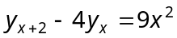.
(b) Find the recurrence relation for the Fibonacci sequence.
- (a) Solve the recurrence relation
with 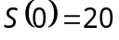 and 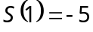.
(b) (i) Assuming that repetitions are not permitted, how many four digit numbers can be formed from six digits 1, 2, 3, 5, 7, 8?
(ii) How many of these numbers are less than 4000?
- (a) 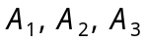 and 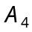 are subsets of a set U containing 75 elements with the following properties. Each subset contains 28 elements ; the intersection of any two of the subsets contains 12 elements ; the intersection of three of the subsets contains
5 elements ; the intersection of all four subsets contains 1 elements.
(i) How many elements belong to none of the four subsets?
(ii) How many elements belong to exactly one of the four subsets?
(b) In how many ways can 2 letters be selected from the set 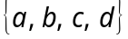 when repetition of the letters is allowed, if
(i) the order of the letters matters
(ii) the order does not matter?
- (a) Show that the number of derangements of a set of n elements is given by
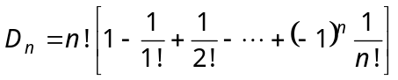.
(b) State and prove the principles of inclusion-exclusion as applied to three finite subsets.
- (a) Write short notes on Polya’s theory of counting.
(b) State and prove Polya’s fundamental theorem.
- (a) State and prove Polya’s generalization theorem.
(b) Explain – principle of counting.
- (a) A hall light is controlled by two switches, one upstairs and one down stairs. Design a circuit so that the light can be switched on or off from the upstairs or the downstairs.
(b) Using Karnaugh maps, simplify 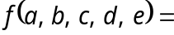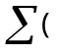0, 1, 3, 8, 9, 13, 14, 15, 16, 17, 19, 24, 25, 27, 31)
- (a) Prove that
(i) Every chain is distributive lattice.
(ii) Duect product of any two distributive lattices is a distributive lattice.
(b) Define Boolean Algebra. Also state and prove De Morgan’s laws in a Boolean Algebra.
————————

